8. Introduction to Spring, Features, Architecture & Modules

Comparison: Hibernate vs Spring vs Spring Boot

Feature | Hibernate | Spring Framework | Spring Boot
Type | ORM framework | Application framework | Framework built on Spring
Purpose | Object–Relational Mapping (ORM) | Enterprise application development | Rapid application development
Main Focus | Database interaction | Dependency Injection, AOP, MVC | Auto-configuration & microservices
Boilerplate Code | High | Reduced | Very minimal
Configuration | XML / Annotations | XML / Annotations / Java Config | Mostly auto-configured
Database Support | Direct ORM support | Integrates with Hibernate/JPA | Uses Spring Data JPA
Web Development | Not supported | Supported (Spring MVC) | Built-in web starter
Embedded Server | No | No | Yes (Tomcat/Jetty)
Application Setup | Manual | Moderate | Very easy & fast
Dependency Management | Manual JARs | Maven/Gradle | Starter dependencies
Microservices | Not suitable | Possible but complex | Best suited
Production Ready | No | Partial | Yes (Actuator, metrics)
Learning Curve | Moderate | Steep | Easy

Simple Explanation
- Hibernate → Handles database mapping
- Spring → Manages application structure and dependencies
- Spring Boot → Makes Spring applications run fast with minimal setup

Introduction to Spring Framework
Spring Framework is a lightweight, open-source Java framework used to build enterprise-level applications.
It provides comprehensive infrastructure support for Java applications and simplifies development by handling boilerplate code, object creation, and dependency management.
It is widely used to build web applications, REST APIs, microservices, and enterprise systems.
Features of Spring Framework
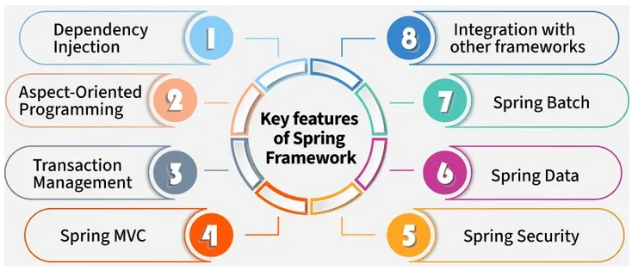
Feature | Description
Lightweight | Uses POJOs and avoids heavy containers
Inversion of Control (IoC) | Object creation and lifecycle managed by Spring
Dependency Injection (DI) | Automatically injects dependent objects
Aspect-Oriented Programming (AOP) | Separates cross-cutting concerns like logging, security
Transaction Management | Supports declarative and programmatic transactions
Modular Architecture | Allows using only required modules
Loose Coupling | Reduces dependency between components
Integration Support | Integrates with Hibernate, JPA, JDBC, JMS
Web MVC Framework | Supports web and RESTful applications
Test Support | Easy unit and integration testing
Exception Handling | Consistent and unified exception handling
Security Support | Integrates with Spring Security

Architecture of Spring Framework

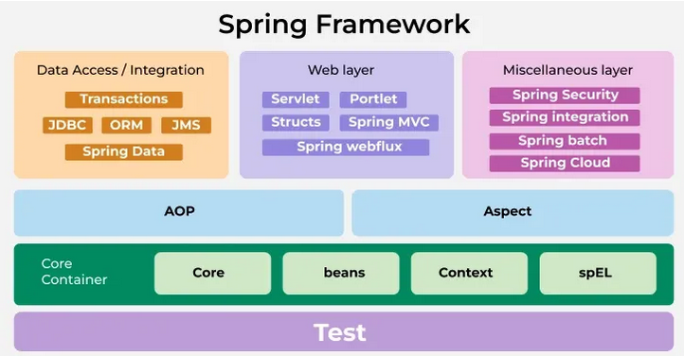

Layer / Component | Sub-Component | Simple Explanation
Core Container | Core | Provides basic Spring functionality and utilities
 | Beans | Responsible for creating and managing Spring beans
 | Context | Provides ApplicationContext, event handling, resource loading
 | SpEL (Spring Expression Language) | Used to evaluate expressions at runtime
AOP Layer | AOP | Supports Aspect-Oriented Programming (logging, security, transactions)
 | Aspect | Defines cross-cutting concerns like logging and security
Data Access / Integration | Transactions | Manages database transactions
 | JDBC | Simplifies JDBC database operations
 | ORM | Integrates with Hibernate, JPA, etc.
 | JMS | Supports messaging using Java Message Service
 | Spring Data | Reduces boilerplate code for data access
Web Layer | Servlet | Builds web applications using Servlet API
 | Portlet | Used for portal-based web applications
 | Struts | Integration support with Struts framework
 | Spring MVC | Builds web and REST applications
 | Spring WebFlux | Supports reactive and non-blocking web applications
Miscellaneous Layer | Spring Security | Provides authentication and authorization
 | Spring Integration | Supports enterprise integration patterns
 | Spring Batch | Used for batch processing jobs
 | Spring Cloud | Builds cloud-native and microservices applications
Test Layer | Test | Supports unit and integration testing

Spring Framework Modules
Module Category | Module Name | Purpose / Description
Core Container | spring-core | Core utilities and framework base
 | spring-beans | Bean creation and Dependency Injection
 | spring-context | ApplicationContext, event handling
 | spring-expression | Spring Expression Language (SpEL)
AOP & Instrumentation | spring-aop | Aspect-Oriented Programming support
 | spring-aspects | AspectJ integration
 | spring-instrument | Class instrumentation support
Data Access / Integration | spring-jdbc | Simplifies JDBC operations
 | spring-orm | ORM support (Hibernate, JPA, etc.)
 | spring-tx | Transaction management
 | spring-jms | Java Message Service support
Web Layer | spring-web | Web utilities and REST support
 | spring-webmvc | Spring MVC framework
 | spring-webflux | Reactive web applications
Messaging | spring-messaging | STOMP & messaging support
Testing | spring-test | Unit and integration testing support

- Spring Core Module:
- The core component providing the IoC container for managing beans and their dependencies.
- It includes BeanFactory and ApplicationContext for object creation and dependency injection.
- Spring AOP Module:
- Implements Aspect-Oriented Programming to handle cross-cutting concerns like transaction management, logging and monitoring, using aspects defined with the @Aspect annotation.
- Spring ORM Module:
- Provides APIs for database interactions using ORM frameworks like JDO, Hibernate and iBatis.
- It simplifies transaction management and exception handling with DAO support.
- Spring Web MVC Module:
- Implements the MVC architecture to create web applications.
- It separates model and view components, routing requests through the DispatcherServlet to controllers and views.
- Spring DAO Module:
- Provides data access support through JDBC, Hibernate or JDO, offering an abstraction layer to simplify database interaction and transaction management.
- Spring Application Context Module:

Builds on the Core module, offering enhanced features like internationalization, validation, event propagation and resource loading via the ApplicationContext interface.

Evolution of Spring Framework

Version | Year | Key Features / Enhancements
Spring 1.0 | 2004 | Introduction of IoC and Dependency Injection
Spring 2.0 | 2006 | Annotation-based configuration, AOP improvements
Spring 2.5 | 2007 | Component scanning, stereotype annotations
Spring 3.0 | 2009 | Java-based configuration, SpEL, REST support
Spring 3.1 | 2011 | Environment abstraction, profiles
Spring 4.0 | 2013 | Java 8 support, WebSocket support
Spring 4.3 | 2016 | Improved annotation usage, REST enhancements
Spring 5.0 | 2017 | Reactive programming (WebFlux), Java 9 support
Spring 5.1–5.3 | 2018–2020 | Performance improvements, Kotlin support
Spring 6.0 | 2022 | Java 17 baseline, Jakarta EE namespace
Spring 6.1+ | 2023–Present | Performance, observability, cloud-native improvements

What is Boilerplate Code?
Boilerplate code is repetitive, standard code that is required in many programs but does not contain business logic.
It is necessary to make the program work, but writing it again and again is boring and time-consuming.

Example in Java (Without Spring)

Connection con = DriverManager.getConnection(url, user, pass);
PreparedStatement ps = con.prepareStatement("SELECT * FROM student");
ResultSet rs = ps.executeQuery();
This code is repeated in many programs → boilerplate code

Example with Spring JDBC
jdbcTemplate.query("SELECT * FROM student", rowMapper);

How Spring Reduces Boilerplate Code
Spring handles:
- Object creation
- Dependency injection
- Transaction management
- Exception handling

REST Applications
REST stands for REpresentational State Transfer.
REST applications are applications that communicate over the internet using REST principles and HTTP methods to exchange data, usually in JSON or XML format.

HTTP Methods Used in REST
Method | Purpose
GET | Retrieve data
POST | Create new data
PUT | Update existing data
DELETE | Delete data

Characteristics of REST Applications
Feature | Explanation
Stateless | Each request is independent
Client–Server | Client and server are separate
Uses HTTP | Works over web protocols
Resource-Based | Uses URLs to identify resources
Data Formats | JSON, XML

REST vs Traditional Web Application
REST Application | Traditional Web App
Returns JSON/XML | Returns HTML pages
Used by apps | Used by browsers
Stateless | Often session-based

POJO Class
POJO stands for Plain Old Java Object.
A POJO class is a simple Java class that:
- Does not depend on any framework
- Does not extend any special class
- Does not implement any special interface
- Contains only fields, constructors, getters, setters, and methods
A POJO class is a normal Java class used to represent data without framework restrictions.
Aspect-Oriented Programming (AOP)
It means separating common functionality (like logging, security, transactions) from business logic.
AOP allows developers to handle cross-cutting concerns separately, keeping business logic clean.

These are functionalities used across many modules:
Concern | Example
Logging | Log method calls
Security | Check user authorization
Transactions | Commit / rollback
Exception handling | Common error handling

Without AOP → code repetition
With AOP → centralized handling

Portlets –
Portlets are web components used in portal applications where multiple small applications run on a single web page.

Key Points
- Part of Java Portlet API (JSR-168 / JSR-286)
- One page can contain many portlets
- Used in enterprise portals (HR, banking dashboards)

Example
A portal page with:
- News portlet
- Login portlet
- Weather portlet

Struts –
Struts is an Apache MVC-based web framework used to build Java web applications.

Key Points
- Based on MVC architecture
- Uses Action classes and XML configuration
- Older framework (largely replaced by Spring MVC)

MVC –
MVC (Model–View–Controller) is a design pattern, not a framework.

Components
- Model → Business logic & data
- View → UI (JSP, HTML)
- Controller → Handles requests & responses

Purpose
- Separates UI from business logic
- Improves maintainability

Spring Bean
A Spring Bean is an object that is created, managed, and destroyed by the Spring container.
Any Java object controlled by Spring is called a Bean.

Example of a Bean
@Component
public class Student {
private int id;
private String name;
}
Spring automatically creates this object → Spring Bean

What is SpEL?

SpEL (Spring Expression Language)
SpEL is a powerful expression language used to query and manipulate objects at runtime in Spring.
SpEL is Used for:
- Access bean properties
- Call methods
- Perform calculations
- Conditional logic

Simple SpEL Examples
@Value("#{student.name}")
private String studentName;

@Value("#{student.age > 18}")
private boolean isAdult;

@Value("#{10 + 20}")
private int result;

Part | Meaning
@Value | Injects a value into a variable
#{} | Indicates SpEL expression
10 + 20 | Expression to be evaluated
private int result | Variable that receives the value

